# Harrington Problem Sheet

This set of problems is based on an online bookstore schema (from a set book of a few years ago) as depicted in the diagram below. You need to work your way through the problems over the next few weeks, not only in the practical sessions but in your own time too. If you find that, even after spending some time on a problem, you get stuck, move on to the next problem and come back to it later. You can always ask for some clues but you need to have tried solving the problem first. You will not learn effectively otherwise.

A sensible approach is to make your own version of this Word document to use as a repository for your own solutions. This will enable you to check your solutions against some model solutions which will be published in a few weeks’ time. Also, some problems build on previous problems.

Take care to record your SQL statements and not just the results of a query. Just knowing that the answer is ‘Smith’ is not going to help you remember how you obtained it!

Past students have found this problem sheet and its solutions an invaluable resource on SQL queries, not just for this module but for the rest of their studies and beyond into their careers.

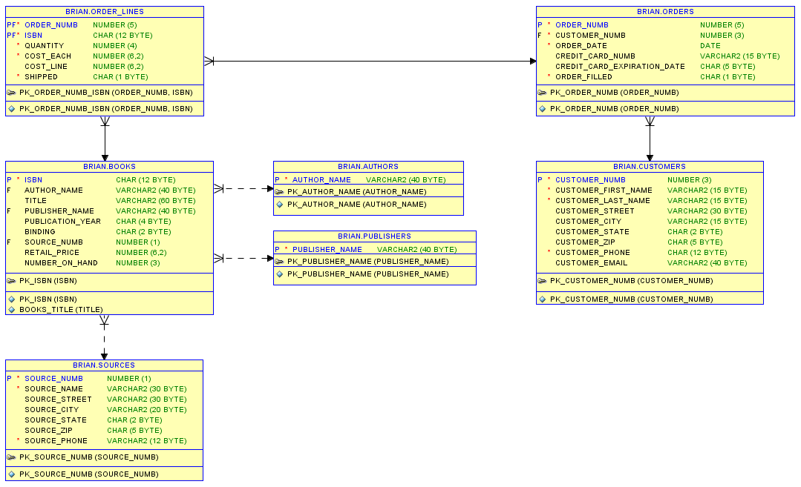

Write SQL queries to solve the following problems:

*N.B. the expected number of rows selected is shown in parentheses. 1 row might just be a single value.*

1. List the full contents of the customers table (14)



1. List the first and last names of all customers (14)



1. List the last names of all customers removing duplicates (6)



1. List the last names of all customers in reverse alphabetical order (14)



1. List customer numbers and full names of all customers living in SM state (4)



1. List customer numbers, full names and state of all customers who do not live in SM state (10)



1. List the order number, ISBN, cost line and cost each for those order lines with the cost line greater than the cost each (7)



1. List the title and publisher of any book written by Edgar Rice Burroughs which was published before 1970 (4). HINT: Check the format of author name.



1. List the title and publisher of any book written by Edgar Rice Burroughs which was published between 1970 and 1974 (2)

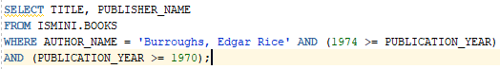

1. List any author name beginning with 'Ch' (1)



1. List titles of books with the string 'Faded' in the title (2)



1. List customer names and email addresses for those customers whose email address ends in '@this.net' (3)



1. List the customer names and states of customers living in SU, SM, SX or ST states (12)

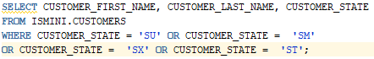

1. List the order numbers and dates for orders placed by Peter Johnson (3). HINT: You need more than one table here.

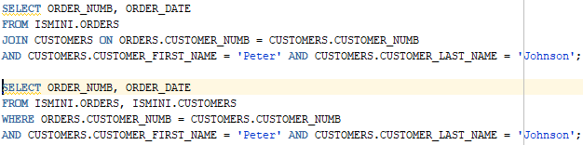

1. List the customer numbers of customers who have orders with books that have not shipped (9)

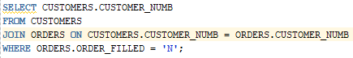

1. List the ISBN, author and title of books that have not shipped (24)

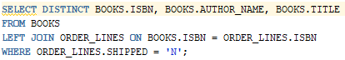

1. List the unique ISBNs of books ordered by Peter Johnson (10)

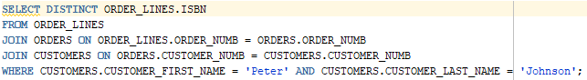

1. List the authors and titles of books ordered by Peter Johnson (10)

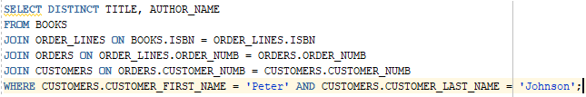

1. List pairs of customer names with the same zip code (11). HINT: Your output should have four columns: CUSTOMER_FIRST_NAME, CUSTOMER_LAST_NAME, CUSTOMER_FIRST_NAME, CUSTOMER_LAST_NAME and you need to access the same table twice.

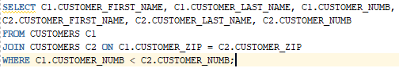

1. Rewrite 14 as a subquery (3)

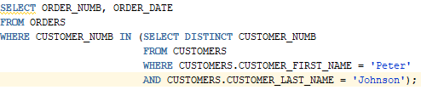

1. List the ISBN, retail price, cost_each price and the difference in price for any book whose retail price is not the same as its cost_each price (1)

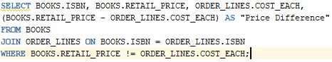

1. List authors of books published by Atheneum or Delacorte (use set union) (3)



1. List authors of books published by Atheneum and Delacorte (use set intersection) (1)



1. List authors who have books published by Atheneum but not by Delacorte (use set difference) (2)



1. List the customer number, order number and order date for orders placed on 07-JUN-2000 (2)



1. List the customer number, order number and order date for orders placed on 07th June 2000 – you must use this date format in your WHERE clause and to format order_date in your output (2)
2. 
3. How many different books are available? (1)
4. How many books are in stock (on hand)? (1)
5. How many books does each publisher publish in decreasing order? (33)
6. List publishers who do not have any books in the system (3)
7. How many orders does each customer have (include those customers without any orders)? (14)
8. List the order number, customer number, customer name, order date and cost of order for each order in decreasing cost of order (25)
9. In reverse date order, list the customer number, customer name and the date of the last order placed by the customer (exclude those customers without any orders) (12)
10. What is the total cost of all orders? (1)
11. What is the total cost of all filled orders? (1)
12. List the order number, order date and order status in ascending order of order_date (84). An order which has been filled (*Y*) should be shown as **order filled**. An order that has not been filled (*N*) should be shown as **order NOT filled**. An order with any other order_filled value should be shown as **status not known**
13. List the author name, title, publication year and category of book by publication year in alphabetical order of author name (70). The value for category is defined as:

published before 1900 **19th Century**

published between 1900 and 1938 **Pre-War**

published after 1970 **Modern**

any other books are **not categorised**

1. What is the total cost of the entire stock? (1)
2. What is retail price of the most expensive book? (1)
3. On what date was the last order placed? (1)
4. What is today’s date? (1)
5. What time is it now? (1)
6. How many days have elapsed since the last order was placed? (1)
7. How many months have elapsed since the last order was placed? (1)
8. What is 18 divided by 30? (1)
9. What is the date of the last day of the current month? (1) HINT: you will need to consult the Oracle SQL Reference documentation
10. What day of the week is the last day of the current month? (1)
11. What is the cost of the most expensive order? (1)
12. Find the name of the customer who has placed the most expensive order (1)
13. List the total amounts spent by each customer including those customers who have not spent any money (14)
14. Find the name of the customer who has spent the most money (1)
15. List the ISBNs of other books that have been bought by customers who have bought the book with the ISBN '0-191-4934-8' (22)
16. List the customer number, order number and order date for the most recent order for each customer in ascending order of customer number (12)
17. List the ISBNs of the top 5 most popular books by number sold (5)
18. List the ISBNs of the top 3 most popular books by number sold. HINT: your solution should be able handle ties (5)

